**How to do Bulk Check in:**

**Open Application Definition & Open Ruleset:**

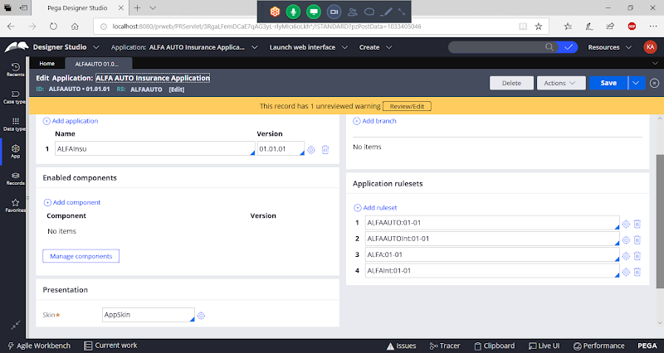

**Open Ruleset**

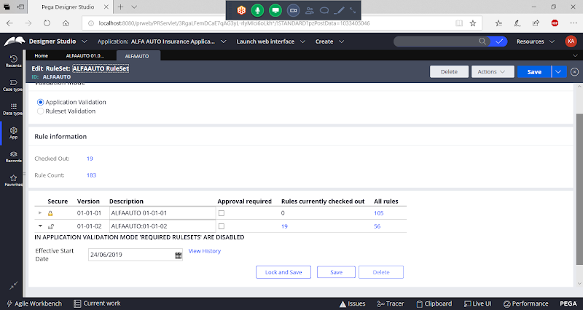

**If you try to lock Rulset Version 01-01-02 you will get error message.**

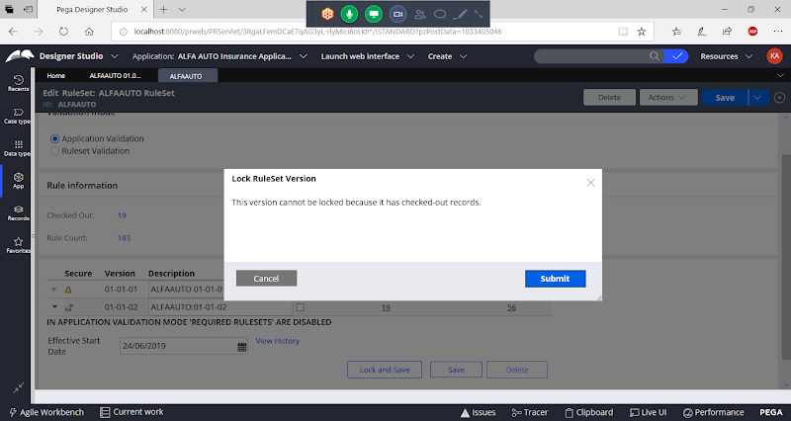

**We cannot check in every rule manually, instead we can do bulk check-in.**

**BULK Check-In**

**To Open Bulk check in wizard, In header next to search box, click on Private Menu:**

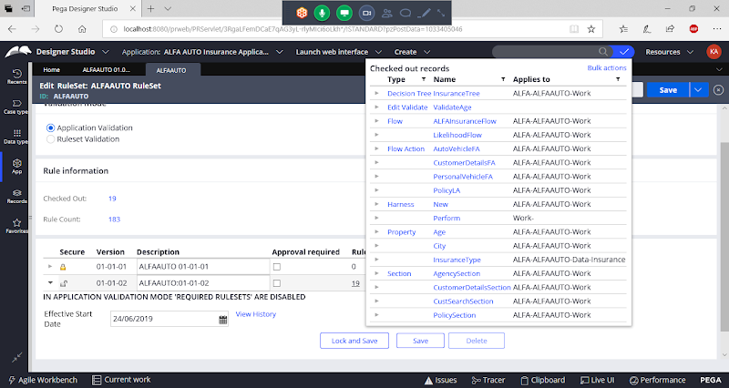

**Click on Bulk Actions**

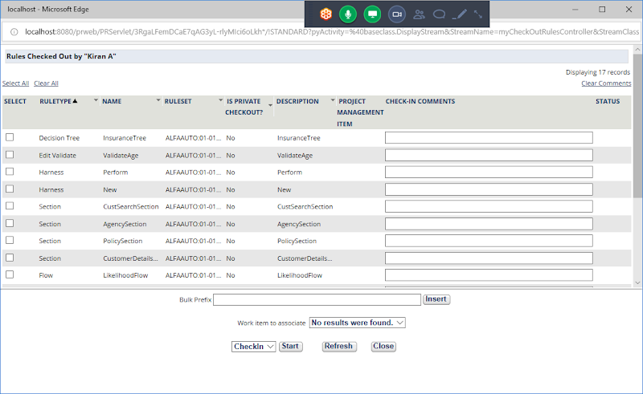

**Click on Select All**

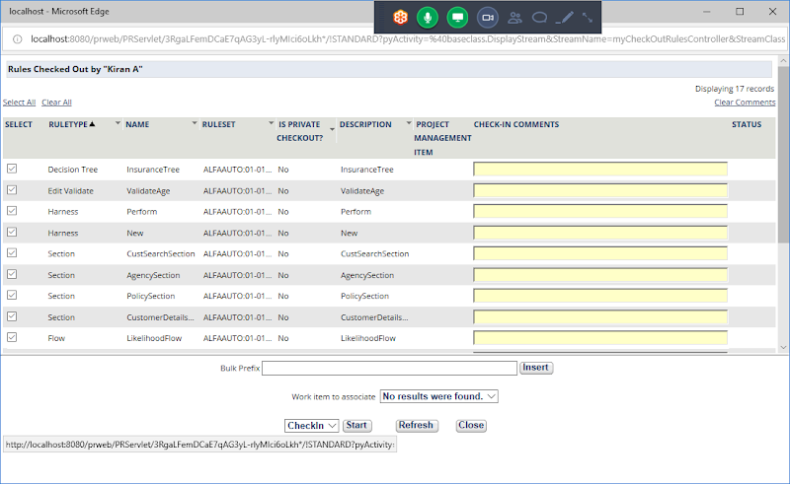

**Now Enter any value in Bulk Prefix:**

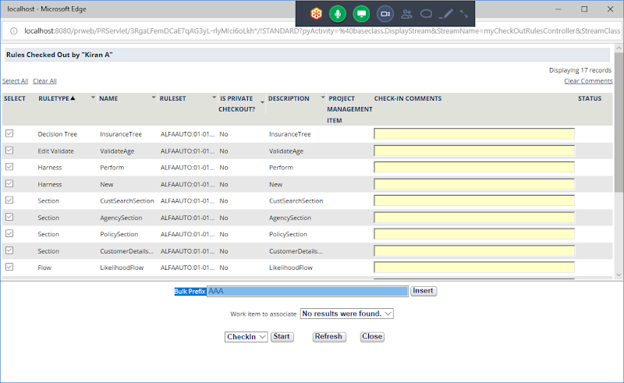

**Click on Insert**

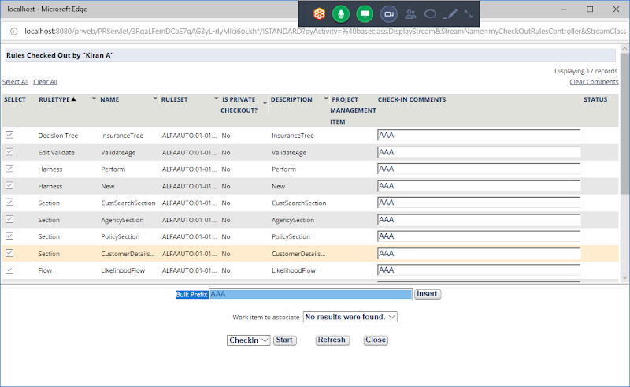

**Now Check-in Click on Start Button**

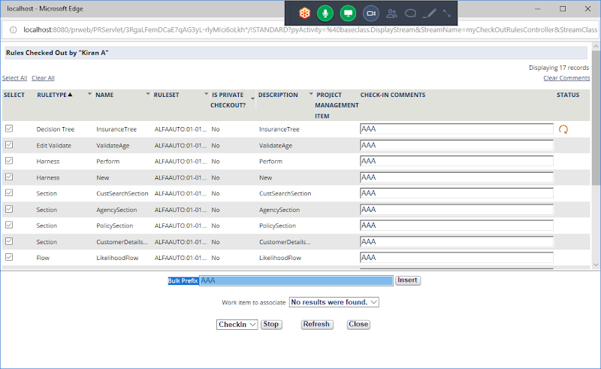

**Now it will start to Checkin All rules one by one**

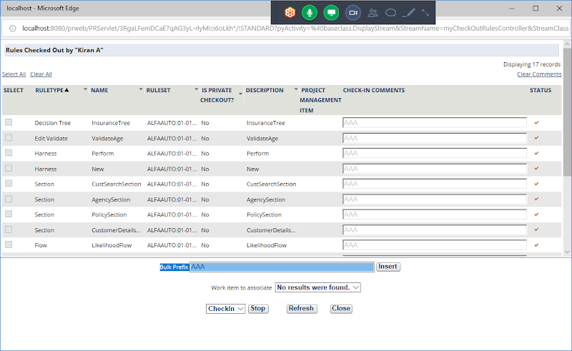

**Once done you can click on Close**

**Open Ruleset Form & Refresh**

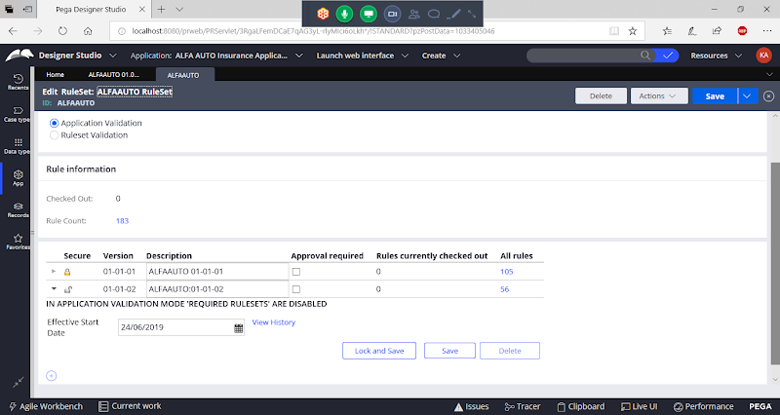

**Now You can Lock Version 01-01-02**

**Click on Lock & Save**

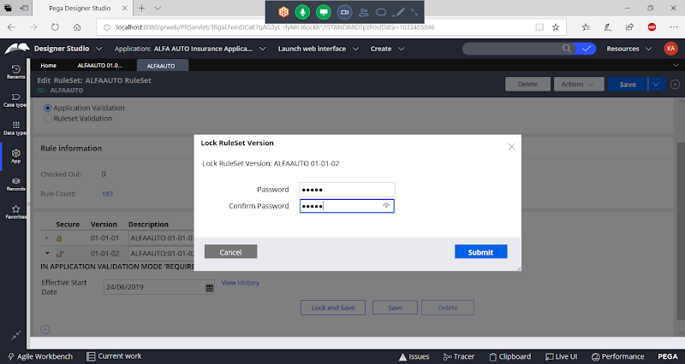

**Submit**

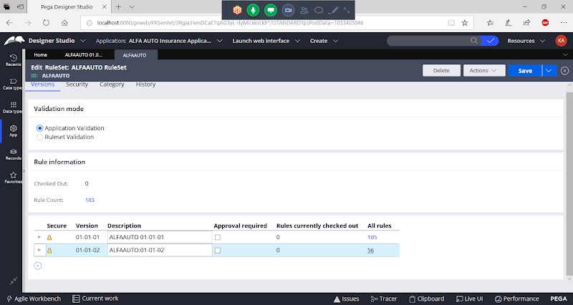

**Now Add a New Version**

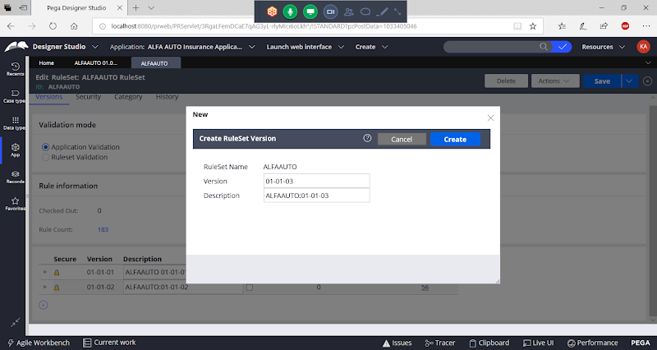

**Create**

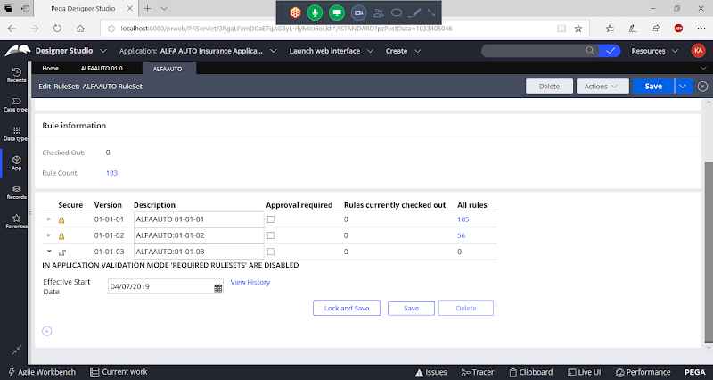

**Save Ruleset Form**